**IntelliJ Idea tips & tricks**

1. Increase maximum copy history to 50

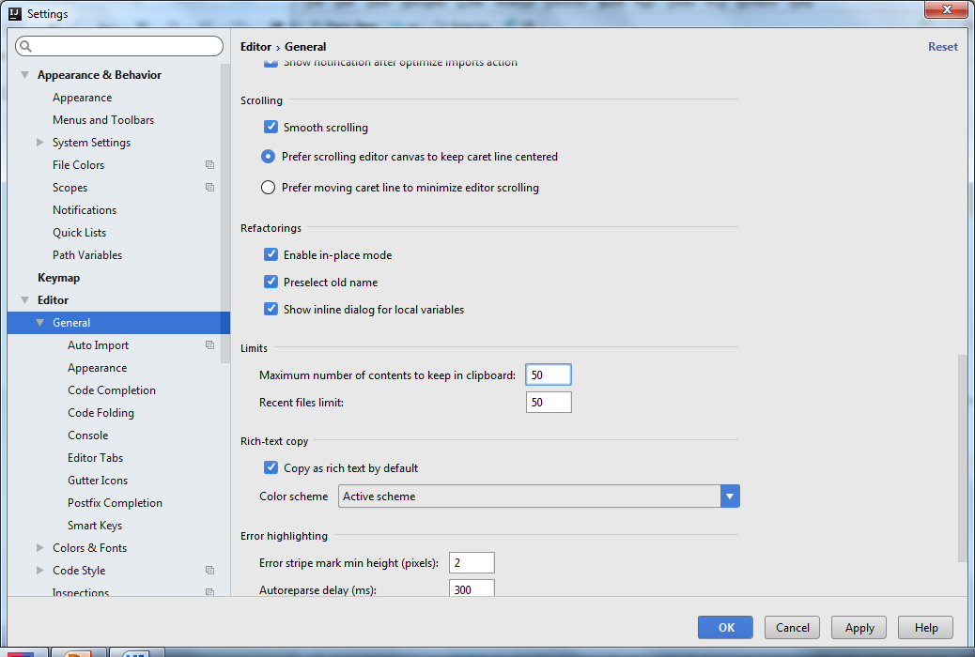

1. Enable show line number, method separator, right margin

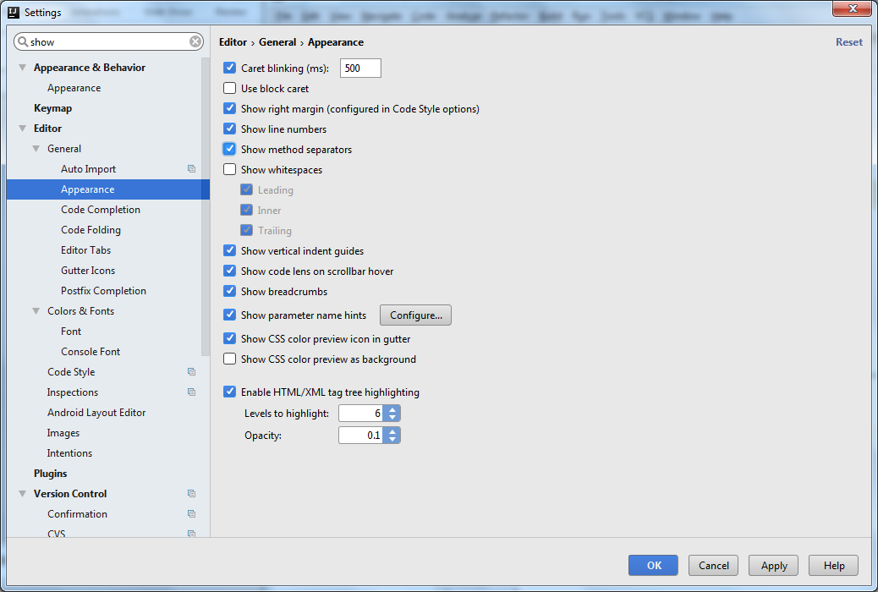

1. Indentaion of 4,4,8

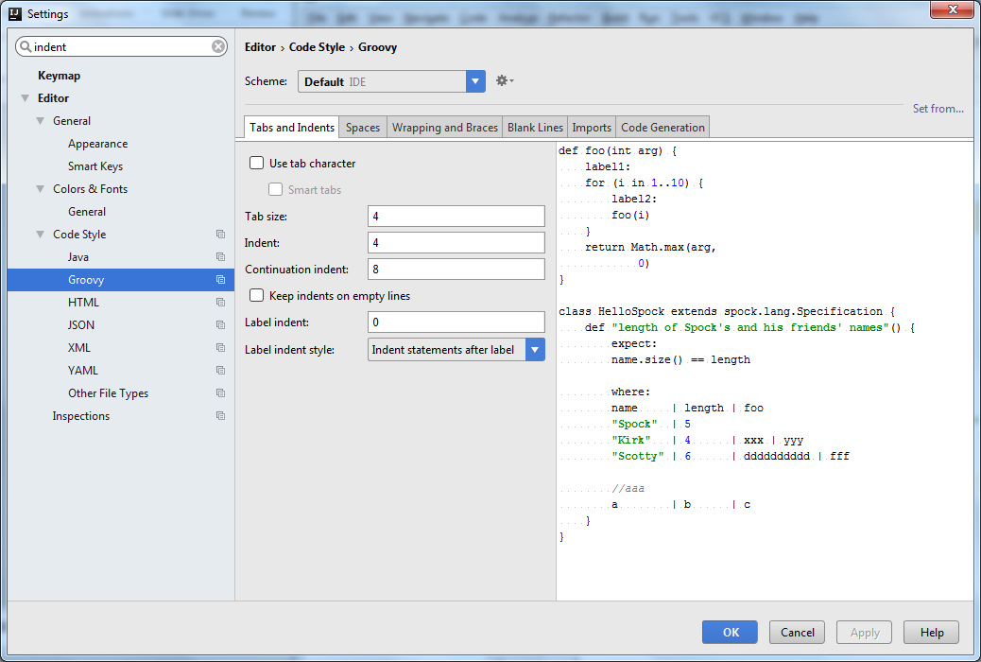

1. Create Live Templates
   * prt for println

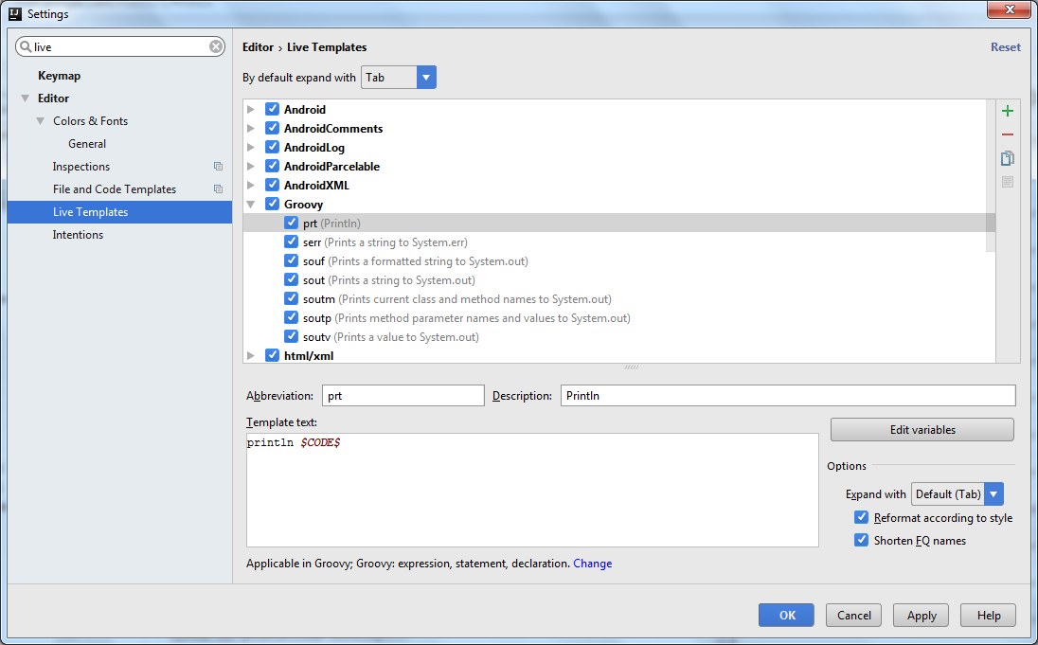

* + surround with try catch

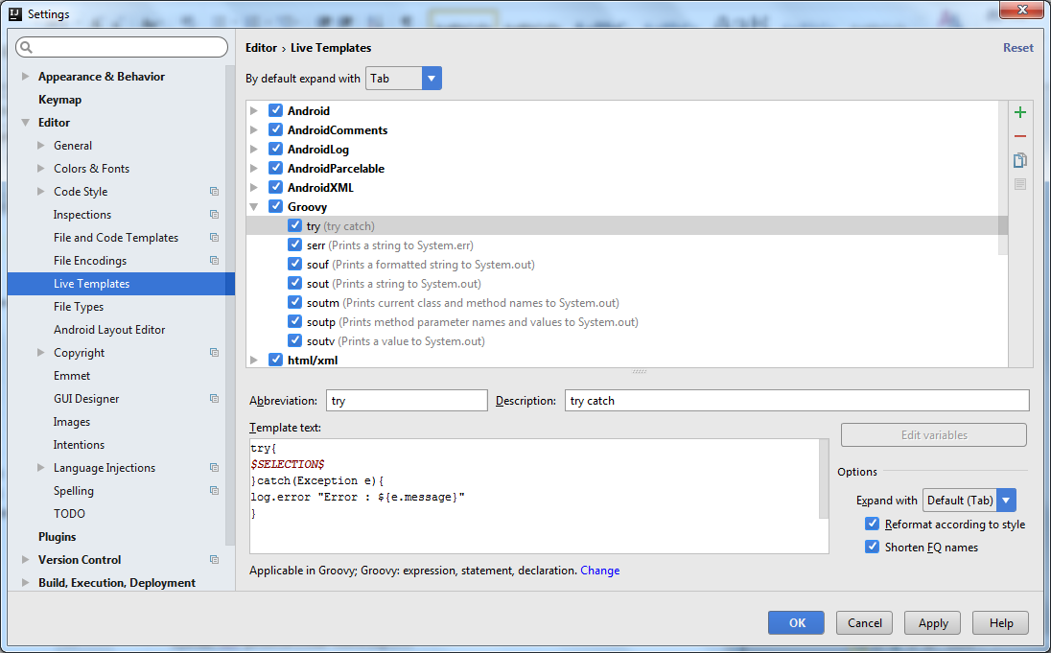

* swt for setup: when: then:

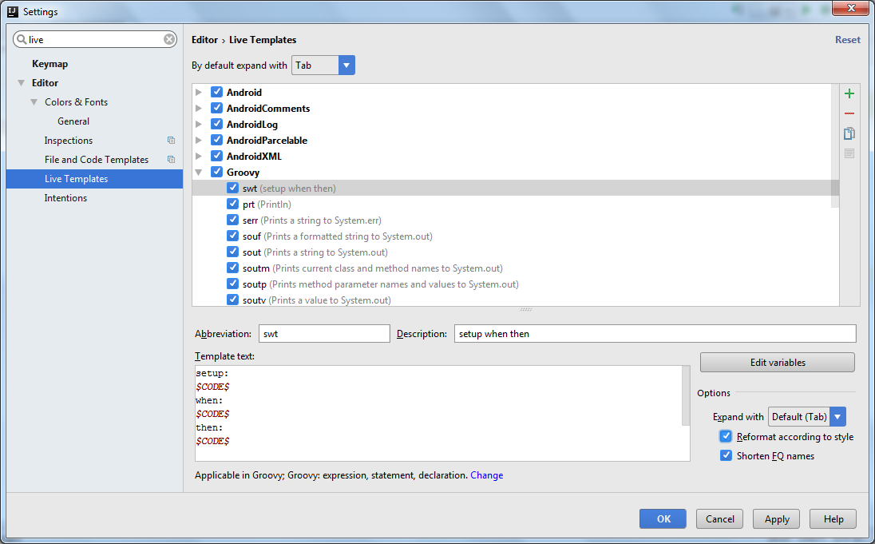

* surround with if

